Contributor: Imma Ramos

**Surrealism in Latin America**

Surrealism was officially founded as a cultural movement in 1924 in Paris with group leader **Andre Breton**’s *Surrealist Manifesto*, which expressed the movement’s aims: to show new, imaginative ways of seeing the world, and through this vision change society. The Surrealists aimed to stimulate debate about the role of the unconscious and sexual repression in the construction of the individual. They wanted to disturb, shock and ultimately liberate society from conventions, and they did this by tapping into their own unconscious to find a new way of representing the world and also that of the viewer, to psychologically challenge and surprise them. From the 1920s onward, the impact of the artistic movement spread internationally. The Surrealists felt that Latin America in particular perfectly articulated their own values and aims. Culturally, they understood it to be a land teeming with imagination, myth and magic that set it apart from the rational West. Local artists soon became associated with the movement, including **Frida Kahlo**, **Rufino Tamayo** (both from Mexico), **Wilfredo Lam** (from Cuba) and **Roberto Matta** (from Chile), as well as several European Surrealists who moved to the region including **Remedios Varo** and **Leonora Carrington.**

Surrealist painters constructed dreamlike images, either painted in a super-real representational technique or constructed in near-abstract shapes using automatism and chance to unlock the artist’s instinctive source of creativity. The Surrealists’ experience of Latin America at first centered on Mexico, when Breton paid a visit there in 1938 and described it as “the surrealist country par excellence.” Art there, he felt, was intrinsically tied to magic. Surrealism was introduced to Mexico City in 1940 with the International Surrealist Exhibition at the Galeria de Arte Mexicana, organized by Breton, the Peruvian poet **Cesar Moro** and the Austrian artist **Wolfgang Paalen**. Included in the exhibition were works by Matta, Moro, Varo, **Frida Kahlo** and **Antonio Ruiz**. The latter’s *Dream of Malinche* (1939) reveals the influence of the Belgian Surrealist **Rene Magritte** with its playful juxtaposition of the corporal with the earth, and the exterior with the interior, painted with illusionistic precision.

The Mexican artist Frida Kahlo (1907-1954) is primarily known for her uncompromising and confessional self-portraits drawing on her experiences of marriage with **Diego Rivera**, her miscarriages and painful surgical operations. Her style combines elements of Surrealism, Symbolism and Realism, while her sources lay in pre-Columbian imagery and colonial Christian symbolism. Her *Love Embrace of the Universe* (1949) represents her in the guise of the Virgin Mary, holding her husband Rivera as if he were the infant Christ. Embracing the couple is the Aztec Earth Mother, Cituacoatl. “My surprise and joy,” Breton wrote of Kahlo, “was unbounded when I discovered, on my arrival in Mexico, that her work has blossomed forth, in her latest paintings, into pure surreality, despite the fact that it had been conceived without any prior knowledge whatsoever of the ideas motivating the activities of my friends and myself.” Kahlo commented: “They thought I was a Surrealist, but I wasn't. I never painted dreams. I painted my own reality.”

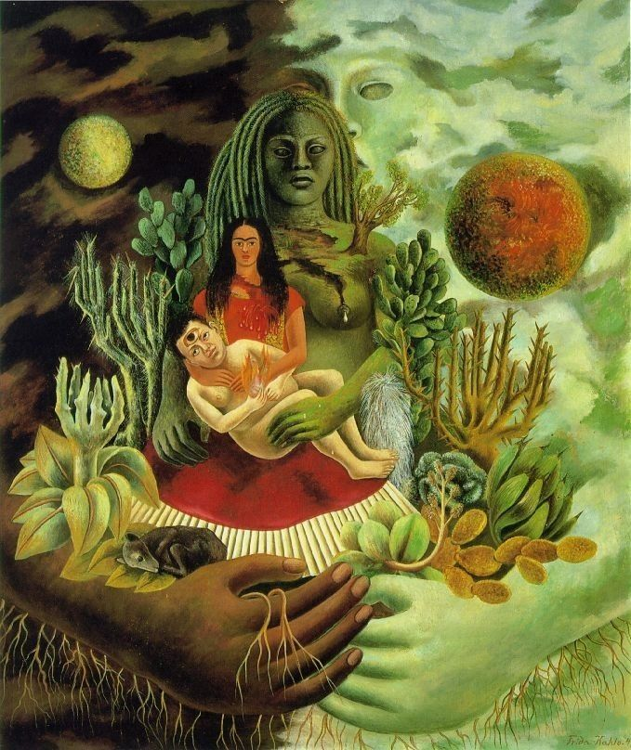

Frida Kahlo, *The Love Embrace of the Universe*, 1949, oil on canvas, Collection of Jorge Contreras Chacel (Mexico City).

Source: [http://uploads6.wikipaintings.org/images/magdalena-carmen-frieda-kahlo-y-calder%C3%B3n-de-rivera/the-love-embrace-of-the-universe-the-earth-mexico-myself-diego-and-se%C3%B1or-x%C3%B3lotl-1949.](http://uploads6.wikipaintings.org/images/magdalena-carmen-frieda-kahlo-y-calder%C3%B3n-de-rivera/the-love-embrace-of-the-universe-the-earth-mexico-myself-diego-and-se%C3%B1or-x%C3%B3lotl-1949.jpg)jpg

Similarly, Breton singled out the paintings of the Haitian **Hector Hyppolite** (1894-1948), who claimed to be a voodoo priest, as quintessentially Surrealist, despite the fact that his works reflected his own reality and religion. His *Ogoun Ferraille* (1944) represents the voodoo warrior god Ogoun, whose attribute is the thunderbolt. Breton also acknowledged Tamayo (1899-1991) among the Surrealists. Like Kahlo, his colourful representations of figures and animals were inspired by popular art forms. During the 1940s, Tamayo began a series of paintings inspired by pre-Columbian ceramic dogs. The animals also assumed contemporary resonance as representations of anger and the horrors of the Second World War.

Like Kahlo, the exiles Varo (1908-1963) and Carrington (1917-2011) also drew on their personal experiences as marginalised female artists within a male dominated art movement. They had been associated with the Surrealists since the 1930s but it was only after they moved to Mexico in the 1940s that their oeuvre flourished, fuelled by artistic freedom and independence. Both were inspired by their studies of mythology, oriental philosophy, medieval alchemy and witchcraft. Their styles drew on Surrealist subject matter combined with the meticulous technique of medieval painting. Varo’s paintings portray imaginary, androgynous, sometimes half-animal characters in confined spaces, often in the magical act of creation, as in for example *Creation of the Birds* (1957). Carrington was introduced to the Surrealist circle in Paris by the artist **Max Ernst**. Her paintings are often satires of patriarchy and many represent esoteric subjects. *The Temptation of Saint Anthony* (1947) is influenced by a painting of the same title by Hieronymous Bosch, whose sixteenth-century proto-surrealist renderings of monstruous creatures were a major source of inspiration for both Varo and Carrington. Here Carrington adapts the story of the hermit saint to include ambiguous feminine sprite-like figures performing rituals around him. Many of her works of the 1950s represent such feminine figures as powerful priestesses overseeing rituals.

Both the Cuban artist Lam (1902-1982) and Chilean Matta (1911-2002) had travelled to Paris and become affiliated with the Surrealists during the 1930s. Lam subsequently returned to Havana where he increasingly drew on his own Afro-Cuban heritage in his work, including allusions to Santería(the popular Cuban religion fusing elements of Christianity with Yoruba African belief), which he combined with a unique stylistic synthesis of Surrealism and Cubism. His most celebrated painting, *The Jungle* (1943), swarms with masked hybrid creatures, half-animal, half-human. They emerge from a tropical mass of vegetation, alluding to a sugar plantation deliberately represented as a symbol of servitude, reflecting Lam’s own concerns about the exploitation of the black Cuban population. Matta experimented with Surrealist automatism techniques involving thin layers of paint which he would wipe and sponge to reveal underlying forms. Such methods would result in paintings he referred to as ‘inscapes’ (representations of the artist’s psyche as interior landscapes) which he worked on during the late 1930s. In works such as *Psychological Morphology* (1938) he invented shapes from the unconscious. These almost abstract forms seem to be biomorphic, in the process of metamorphosing or becoming. They are archetypes of universal human experience alluding to life, death, sex and nature.

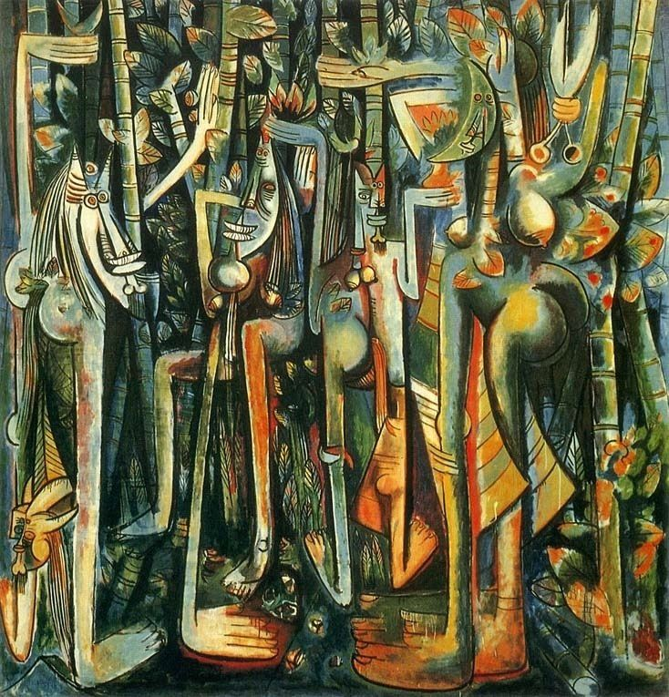

Wifredo Lam, *The Jungle*, 1943, gouache on paper, Museum of Modern Art (New York).

Source: <http://www.matta-art.com/lam/jungle.jpg>

**Further reading:**

Aberth, S. (2004) *Leonora Carrington - Surrealism, Alchemy and Art.* Aldershot: Lund Humphries.

Ades, D.; Eder, R. and Speranza, G. (2012) *Surrealism in Latin America: vivisimo muerto.* London: Tate Publishing.

Ashton, D. (1993) “Surrealism and Latin America” in Rasmussen, W. *Latin American artists of the twentieth century.* New York: The Museum of Modern Art.

Barnitz, J. (2000) *Twentieth-century art of Latin America*. Austin: University of Texas.

Breton, A. (1972) *Surrealism and painting*. London: Macdonald and Co.

Herrera, H. (1998) *Frida: a biography of Frida Kahlo*. London: Bloomsbury.

Kaplan, J. (1988) *Unexpected Journeys: the art and life of Remedios Varo*. New York: Abbeville.

Leiris, M. (1973) *Wilfredo Lam*. S.I.: Abrams.

Matta, R. (1975) *A Totemic World: paintings, drawings, sculpture*. S.I.: Andrew Crispo Gallery.

**List of Works:**

Leonora Carrington, *The Temptation of St Anthony*, 1947, oil on canvas, Museo del Prado (Madrid).

Wifredo Lam, *The Jungle*, 1943, gouache on paper, Museum of Modern Art (New York).

Frida Kahlo, *The Love Embrace of the Universe*, 1949, oil on canvas, Collection of Jorge Contreras Chacel (Mexico City).

Antonio Ruiz, *Dream of Malinche*, 1939, oil on canvas, Galeria de Arte Mexicano (Mexico City).

Hector Hyppolite, *Ogoun Ferraille*, 1944, oil on cardboard, collection of Elisa Breton (Paris).

Rufino Tamayo, *Animals*, 1941, oil on canvas, Museum of Modern Art (New York).

Remedios Varo, *Creation of the Birds*, 1957, oil on masonite, private collection.

Roberto Matta Echaurren *Psychological Morphology*, 1938, oil on canvas, Art Institute of Chicago.